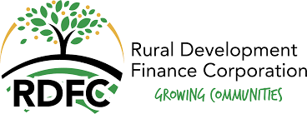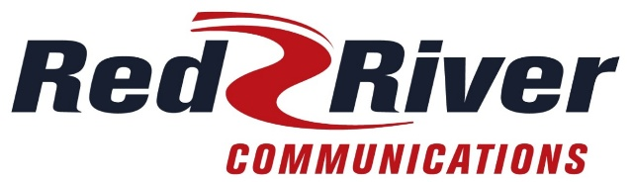
2026 Grant Application
Those interested in receiving a grant through RDFC need to work directly with their local cooperative.

PROJECT INFORMATION
Project Title:________________________________________________________________________
Recipient: ___________________________________________________________________________
Recipient Contact: __________________________________________________________________
Recipient Mailing Address (include street address, city, state & zip code):
___________________________________________________________________________________
Recipient Phone #: ________________ Recipient Email: _________________________________
Request from RDFC: $_______________ Total Project Costs: $______________________________
(max. $2,000 / min. $500) *requires $2,000 minimum in other funds for a $500 RDFC grant

Project Location: ____________________________________________________________________
Recipient Tax ID Number: ____________________________
Check one: _____ Community-owned business or facility (i.e. ambulance, hospital, fire district,
recreation, community center, etc.)
_____ Community-based project (i.e. service group/club; youth/school programs, etc.)
How will the grant funds be used? (Funds are to be used for community betterment and/or economic development projects (i.e.: café, grocery store, motel; ambulance services, fire districts, recreation; school/youth projects, etc.) Please note that RDFC does not provide funds for medical fundraisers or general operating costs. ____________________________________________________________________________________
____________________________________________________________________________________

Funding Sources:
Local Incentive Funds $_____________
State Funds $ _____________
Federal Funds $_____________
City $_____________
County $_____________
RDFC Member Co-op $_____________
Bank $_____________
RDFC request $_____________
Other $_____________ (Please list) _______________________________
Total: $_____________ *must equal total project costs listed above
+++++++++++++++++++++++++++++++++++++++++++++++++++++++++++++++++++++++++
RDFC-MEMBER INFORMATION (Utility Cooperative to fill out)
RDFC Member Cooperative: ___Red River Communications __________________________________________ Contact Person: ____Donna Thiel__________________ Title: _______Executive Assistant_________________
Phone Number: ____701-553-8243____________ Email address: ______donnathiel@redrivercomm.com_______
Mailing Address: ___PO Box 136, Abercrombie, ND 58001-0136________________________________________

__________________________________________ ______________________________
Signature of RDFC Authorized Member Date

